6.

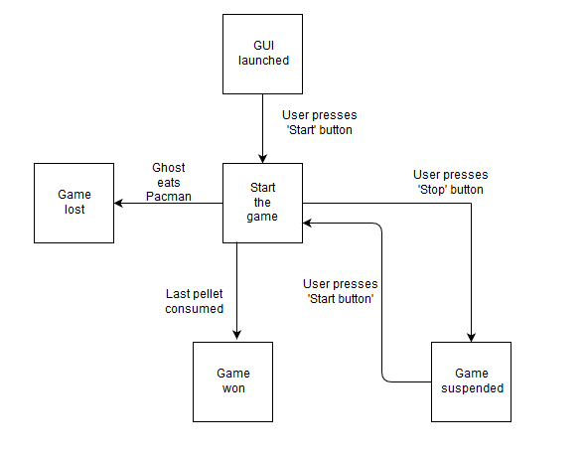

7.

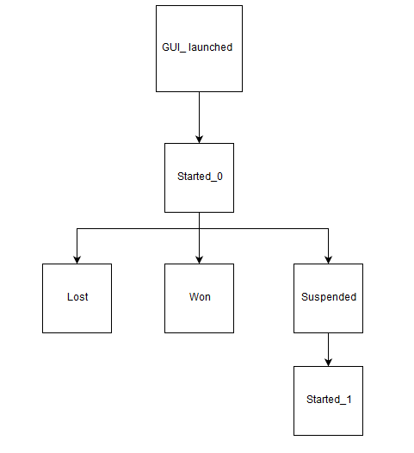

8.

|  |  |  |  |  |
| --- | --- | --- | --- | --- |
| States | Events | | | |
|  | Start button pressed | Ghost eats Pacman | Last pellet consumed | Stop button pressed |
| GUI_Launched | Started | - | - | - |
| Started | Started | - | - | - |
| Lost | - | Lost | - | - |
| Won | - | - | Won | - |
| Suspended | - | - | - | Suspended |

All the test cases (sorted by events):  
- Start button has been pressed and the GUI has been launched  
- Start button has been pressed and the game has started.  
- Start button has been pressed and the player has won.  
- Start button has been pressed and the player has lost.  
- Start button has been pressed and the game has been suspended.  
  
- Stop button has been pressed and the GUI has been launched  
- Stop button has been pressed and the game has started.  
- Stop button has been pressed and the player has won.  
- Stop button has been pressed and the player has lost.  
- Stop button has been pressed and the game has been suspended.

- Last pellet has been consumed and the GUI has been launched  
- Last pellet has been consumed and the game has started.  
- Last pellet has been consumed and the player has won.  
- Last pellet has been consumed and the player has lost.  
- Last pellet has been consumed and the game has been suspended.

- Ghost has eaten Pacman and the GUI has been launched  
- Ghost has eaten Pacman and the game has started.  
- Ghost has eaten Pacman and the player has won.  
- Ghost has eaten Pacman and the player has lost.  
- Ghost has eaten Pacman and the game has been suspended.